Tasman the Sailor Dog

Tasman the Sailor Dog is a book aimed at awareness of WATER SAFETY
through the eyes of a little Jack Russell Terrier, Tasman.

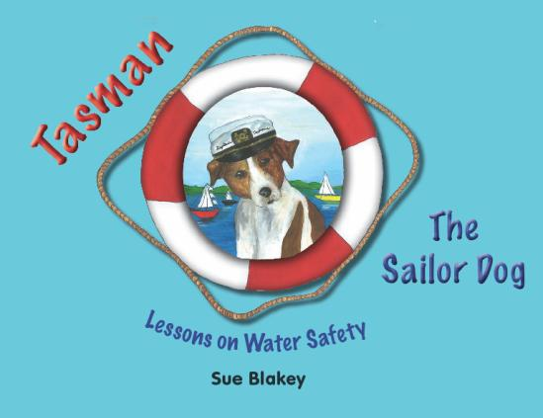

.
Tasman is a very appealing 10 year old Jack Russell Terrier. He loves the sea and has been boating since he was a puppy. His antics in and around water and his love of children provided the inspiration for this book.
Inside the book you will find bright pictures of Tasman and his friends participating in various water activities, aiding awareness of and focus on the Water Safety theme.
The book covers all the basics of Water Safety at beaches, in pools, rivers, lakes, various
boating activities and water safety around in the home environment.

Children will learn all about WATER SAFETY from Tasman in this fabulous book

Endorsed by Barbara Kendall “…a must for all New Zealand Families”
Ideal for all children aged 2 -10 years. Written by a Kiwi for Kiwi kids.
All Year 1-6 Classrooms throughout New Zealand should have this book as a teaching resource.

Books are $20 each but for a school ordering more than 10, discount applies.

Fund Raising opportunity: Any school wishing to use the book as a fund raiser, (especially appropriate to help maintain and preserve their swimming pool), the school would receive $10 for every book they sell i.e. half price. This is fundraising with huge benefits apart from the financial income it will generate.
PTAs could get behind this and solve their problems of maintaining school pools and thus allowing their children to learn to swim.

Please see over the page for ordering details

Tasman the Sailor Dog Order Form

Name: School:

Postal Address:

Phone:

Email:

For any order over 6 copies, you pay only $15 per copy. If Schools wish to use the books as a fundraiser any order over 20 copies will earn $10 per copy for your School.

Item: Cost/Item Quantity $

Tasman the Sailor Dog Book $20.00

Postage & Handling Fee $5.00

Payment:

Cheque □ Cash □ Direct Credit □

Please enclose payment to “Starboard Products Ltd‟.
TOTAL $

Mail to: | Starboard Products Ltd  7C Atkin Avenue | Account Details:  Starboard Products
 | Mission Bay  AUCKLAND 1071 | ASB Eastridge  12-3073-0188167-00
Email: | starpro@ihug.co.nz

